Milestone Completion Report

|  |  |
| --- | --- |
| Agreement #: 29526  FY17  Level: Quarterly Milestone  WBS# 2.2.1.108 | Completion Date: March 31, 2017  Scheduled Completion: March 31, 2017  Platform Area: Conversion (Waste-to-Energy) |
| Milestone Title: | Draft supply-cost algorithms and associated data sets to enable the generation of supply-cost curves for each of the current WtE feedstocks (sludge, manure, food waste and FOG). |
| Authors: | Emily Newes, Anelia Milbrandt |
| Participating Researchers: | Alex Badgett (NREL), Richard Skaggs (PNNL) |
| Project Title:  Principal Investigator: | Waste-to-Energy: Feedstock Evaluation and Biofuel Production Potential  Anelia Milbrandt |
| Key Words: | Waste-to-Energy, sludge, manure, food waste, fats, oils and greases, supply curves |
| Reviewed By: | Data inputs provided by various industry and academia representatives (illustrated in more detail below). |

**Milestone Summary**

The waste-to-energy (WTE) resource assessment project is tasked with summarizing the costs of various wet feedstocks (namely food waste, manure, sludge, and fats, oils, and greases [FOG]) and formulating supply curves. In Q1 and Q2 2017, we have been communicating with industry and academia representatives (Table 1) in order to gain a more thorough understanding of the costs associated with these wet feedstocks. The objective of this work is to provide future alternative energy producers with estimates on the potential feedstock costs and thus support decision-making.

**Table 1. Industry and academia representatives who contributed insights into wet feedstock costs. DO NOT DISTRIBUTE**

|  |  |  |
| --- | --- | --- |
| **Name** | **Affiliation** | **Feedstock** |
| Wendy Barrott | Great Lakes Water Authority | Sludge |
| Rob Hallenbeck | Waste Management | Food Waste |
| Mark Rice | North Carolina State University | Swine Manure |
| Kelly Zering | North Carolina State University | Swine Manure |
| Kraig Westerbeek | Smithfield | Swine Manure |
| Mark Stoermann | Newtrient | Dairy Manure |
| Larry Tranel | Iowa State University | Dairy Manure |
| Nicole Rambo | University of Minnesota Beef Team | Beef Manure |
| Shaine Tyson | Rocky Mountain Biodiesel | FOG (brown grease) |

The initial supply curves will be on a national scale because 1) in many cases, the data are not available with smaller spatial resolution 2) the data can be disaggregated later if project scope warrants it.

*Fats, Oils, and Greases*

Prices for FOG have been historically tracked by the National Renderers Association (Swisher 2016) with the exception of brown grease. Current literature puts the price of brown grease at approximately a one- to three-cent discount to yellow grease (Wang 2014). Using these prices, along with the detailed production levels generated in FY2016 (Milbrandt et al. 2017), we arrived at the following preliminary current national supply curve for FOG (Figure 1). We will speak with other industry representatives, such as waste grease transport companies, to gather more information on this topic, namely to understand regional variations.

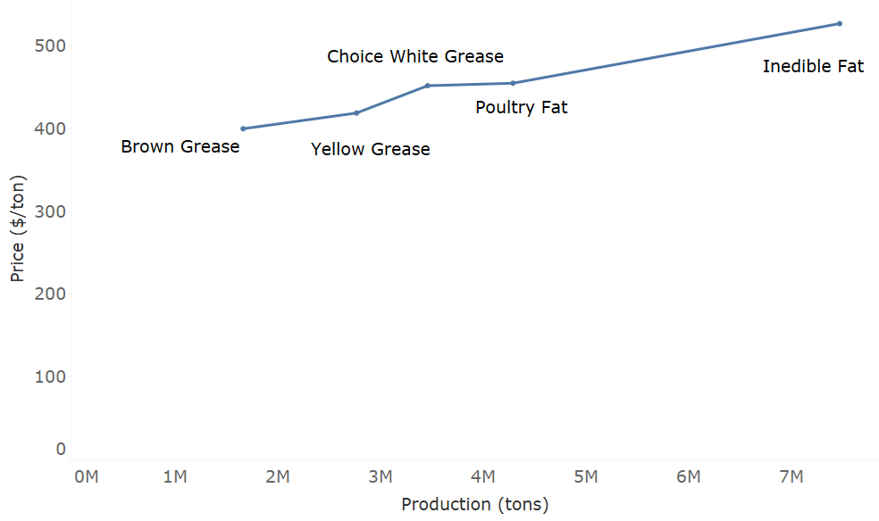

**Figure 1. Preliminary current national supply curve for FOG**

*Food Waste*

There are very few facilities in the United States that separate food waste from the overall waste stream. Mostly, these facilities are built in response to local regulations around limiting the disposal of food waste in landfills. The costs of these facilities are not well publicized. However, a report from Massachusetts estimated the initial cost to separate one ton of food waste per day to be $1,100 and the annual cost to be $1,200 (MDEP 2005). It would be cost prohibitive to use food waste as a feedstock without having a separation facility.

If a separation facility exists, the cost of the feedstock may simply be whatever it costs to transform it into a usable feedstock for the receiving energy production facility. Otherwise, in an environment without regulations that demand such facilities, the cost could be similar to equation 1.

**Disposal site cost = operating costs + transport to site - tipping fee eq. 1**

The cost to operate a refuse truck is around $100/hour (personal communication with Rob Hallenbeck, Waste Management). Landfill tipping fees can be anywhere from $25-100 per ton, with a national average of $52 per ton. We will speak with other industry representatives to gather more information on this topic.

*Manure*

Our analysis considers manure generated at dairy, beef and pig operations. Resource quantities were estimated in FY2016 (Milbrandt et al. 2017). Since these operations are required to manage animal waste, the cost of manure as a feedstock can be seen as an avoided cost. Most manure is applied as a fertilizer on cropland, so from that perspective the value (or price farmers would sell for) is directly tied to the value as a crop nutrient and thus is tied to the local/regional fertilizer prices.

Dairy manure: A study by the Iowa State University estimated the cost of dairy manure at about $120 per cow per year (Bentley and Tranel 2015). These costs include manure storage (structure), storage and handling equipment, storage and equipment depreciation, repairs, taxes and insurance, other expenses (e.g. fuel and supplies), and labor per cow. A dairy cow can produce about 54,020 lbs (27 tons) of wet manure per year, depending on the size and breed of the animal. Thus, the cost of dairy manure would be about $4.44 per ton (in $2015). A participant from west central Iowa in a farmers’ forum indicated that the price of manure is $2 - $4 (in $2013) per ton picked up on the farm. The forum participants also indicated that the value of manure is about 60% - 75% of commercial fertilizer.

Beef manure: Still under investigation. A study by the University of Minnesota Beef Team indicates that the net manure value, gross value minus hauling costs, for solid manure is $6.29 and $7.99/ton for bed-pack and open lots, respectively (Rambo 2016). We have not yet had a discussion with the team to gather more information.

Swine manure: There are regional differences in manure storage and handling systems that affect the cost and value/price of swine manure. In NC, SC and other Southern states, the swine facilities use liquid manure handling systems that require the use of a lagoon or storage pond (manure is flushed from the building and stored outside in lagoons). In the Midwest, swine operations store manure below slotted floors in pits. The deep pit slurry system is far superior to most lagoon systems, as it preserves more nutrients as well as organic matter (Jordahi 2011). Therefore, from a Midwest farmer's perspective, the manure value is directly tied to its value as a crop nutrient and thus tied to the local/regional fertilizer prices; whereas, from a Southeast (NC) perspective, with the lagoon system, the waste as it comes out of storage has a relatively low nutrient density, thus low value, and many farmers would give it away (personal communication with Mark Rice, NCSU). NCSU staff provided some cost parameters for the Southeast to consider in our analysis and a summary is provided below. For the standardized 4,320 head feeder to finish farm, the approximate total cost of manure management is $106.08 per 1,000 pounds Steady State Live Weight (SSLW) per year (in $2017). For a 4,000 sow farrow to wean farm the estimate is $69.03 per 1,000 pounds SSLW per year (NCSU 2004). Deep pit manure (slurry) typically contains between 5-10% solids, while liquid manure (lagoon treatment system) is mostly water with less than 4% solids (typically 2% solids in the Southeast). A solids separator, co-located at the farm, would cost around $104.34 per 1,000 pounds SSLW per year (NCSU 2013). Depending on the amount of solids and the nutrient value of those solids, pig manure is sold for land applications. As mentioned earlier, the price received for the product is tied to the price for traditional fertilizer, which would be considered the lowest price that these farms would be willing to sell their manure to other uses. Otherwise, the cost would approximately be the cost of the dewatering facility. We will continue our discussions with industry and research entities to gather more information and better understand regional differences.

*Sludge*

Similar to manure, the cost of sludge from wastewater treatment plants (WWTPs) can be seen as an avoided cost. Since the facilities are required to dispose of the waste material, they have existing methods for doing so. Any new method would need to be less expensive than existing methods. In other words, the facilities will pay for someone to take their sludge as long as it is less expensive than what they are currently doing. Table 2 contains examples of costs for the Great Lakes Water Authority (Personal communication with Wendy Barrott).

**Table 2. Estimated costs for existing methods of sludge disposal (Great Lakes Water Authority, 2017)**

|  |  |  |
| --- | --- | --- |
| **Item** | **Approximate Cost** | **Notes** |
| Landfill Disposal | $31/wet ton (adding lime) | 8% lime added to sludge |
| Land Application | $46/wet ton (adding lime) | 12% lime added to sludge |
| Transportation | $10/wet ton to landfill + tipping fee | Given typical distance from WWTP |
| Incineration | $15.20/ton (ash – excluding energy costs) |  |
| Biosolids Drying | $177/dry ton | For up to 73,000 dry tons, does not include utilities |

It would make economic sense for this facility to be co-located with the WWTP. Therefore the cost of the feedstock would be this cost minus what the WWTP would pay for you to take its sludge (assuming their current least cost option as the marginal price). We will attempt to find similar cost structures for other large WWTPs, along with current equipment used at these facilities. We will then generalize these data at a national scale for a representative national supply curve. We have very detailed production numbers from work completed in FY2016 (Milbrandt et al. 2017).

**Next Steps**

* Collect additional cost data (regional and in more detail)
* Look into more detail of the cost of manure vs value/price of manure
* Complete national supply curves
* Consult with BETO staff on the desired future supply curves, e.g. finer geographic scale (regional, state), projections.

**References**

Bentley, J., Tranel, L. (2015). “Calculating manure’s price tag”. Hoard’s Dairyman. July 2015. <http://hoards.com/article-16269-calculating-manure%E2%80%99s-price-tag.html>

Jordahi, R. (2011). “Manure Matters.” Pork Network. January 2011. <http://www.porknetwork.com/pork-magazine/features/manure-matters-114019804.html>

Massachusetts Department of Environmental Protection (MDEP). (2005). “Supermarket Composting Handbook”. November 2005. P. 3-5. <http://www.mass.gov/eea/docs/dep/recycle/reduce/m-thru-x/smhandbk.pdf>

Milbrandt, A. Seiple, T., Heimiller, D., Coleman, A., Skaggs, R. (2017). “Wet Waste-to-Energy Resource Assessment”. Pending publication. *Biomass and Bioenergy Journal*.

North Carolina State University. (2004). Project Reports.

<https://www.bae.ncsu.edu/topic/waste-mgmt-center/agreement.html>

North Carolina State University. (2013). “Cost and Returns Analysis of the Terra Blue Generation 3 Manure Management System Evaluated at Jernigan Farms in North Carolina in 2012”. <https://www.bae.ncsu.edu/topic//waste-mgmt-center/CWMTF-report/CWMTF%20Report%20Appendix%20B.2006A-522%20Final%20Report.pdf>

Rambo, N. (2016). “How much is beef manure worth?”. Farm Ranch Guide. October 2016. <http://www.farmandranchguide.com/news/livestock/how-much-is-beef-manure-worth/article_a430029c-8c9f-11e6-82f5-0fa0aa264d64.html>

Swisher, K. (2016). Market Report. Renderer Magazine. April 2016. <http://pubs.rendermagazine.com/2016-04/pubData/source/Render_Apr16.pdf>

Wang, Lijun. (2014)."Food Processing Wastes as an Energy Feedstock: Availability and Sustainability." Sustainable Bioenergy Production. Boca Raton: CRC, Taylor & Francis Group, CRC Is an Imprint of the Taylor & Francis Group, an Informa Business, 2014. N. pag. Print.